**Khyber Pakhtunkhwa:**

Urak Valley

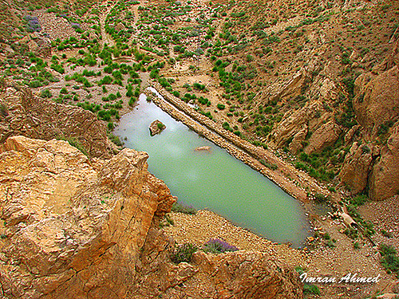

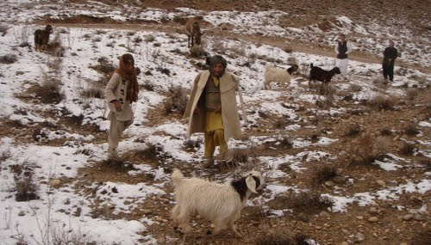

**Urak Valley** is a valley surrounded by mountains in the Quetta District of Balochistan Province, in western Pakistan. Urak Valley is located near Hana Lake, and 21 kilometres (13mi) from Quetta city. A small waterfall at its end marks entrance to the adjacent Wali Tangi Dam. Urak Valley has a population of 10,000, and is nearly 100% Kakar. Agriculture in the valley includes growing apple trees of good quality and a few other fruits.